CEF: Cybersecurity Digital Service Infrastructure;

|  |  |
| --- | --- |
| **Version:** | **4.0.2** |
| **Date:** | **04/11/2019** |

Core Service Platform – SMART 2015/1089

**Central Configuration Manu****al**

Contents

1 Introduction 4

1.1 Connecting to CSP configuration interface 4

1.2 Features of CSP configuration interface 4

2 Management of CSPs 5

2.1 List of CSPs 5

2.2 Updating a registered CSP 6

2.3 Deleting a registered CSP 7

2.4 Register a new CSP 7

3 Management of Modules 9

3.1 List of Modules 9

3.2 Updating a registered Module 10

3.3 Deleting a registered Module 11

3.4 Register a new Module 11

4 Management of a Module’s Versions 13

4.1 Listing Module’s Versions 13

4.2 Updating a registered Module Version 14

4.3 Deleting a registered Module Version 15

4.4 Register a new Module Version 15

5 Monitoring and Assignment of Modules Versions to CSPs 17

5.1 Monitoring organization’s registered CSPs 17

5.2 Assignment of Module’s Versions to organization’s registered CSPs 18

6 ANNEX A: Module File Specification of version 4 19

# Introduction

## Connecting to CSP configuration interface

The CSP configuration management interface can be accessed by logging via SSH port 22 to the VM created for the Central CSP. Login credentials are: user: **root** and password: **systempass** and also add a Port Forward rule for port 19090.

You may use third party software (i.e. PuTTY, as described in section **4.2** of manual: **CSP Installation Manual**) or the command:

* ssh root@{central hostname} -L 19090:localhost:19090

in a Linux terminal, where {central machine hostname} is the hostname or IP of the Central CSP machine.

## Features of CSP configuration interface

CSP configuration interface aims at:

* Managing registered CSP’s or manually register CSPs
* Managing modules available at the organization level and their updates
* Managing modules and their updates that should be delivered to each CSP of the organization

Aforementioned features are presented in details in following chapters and are provided in the top-most menu of the provided interface, as shown below:



# Management of CSPs

Management of CSPs can be accessed via menu “CSPs” from the top most menu of the interface, and the already registered CSPs for the organization are displayed in a table, as shown below:

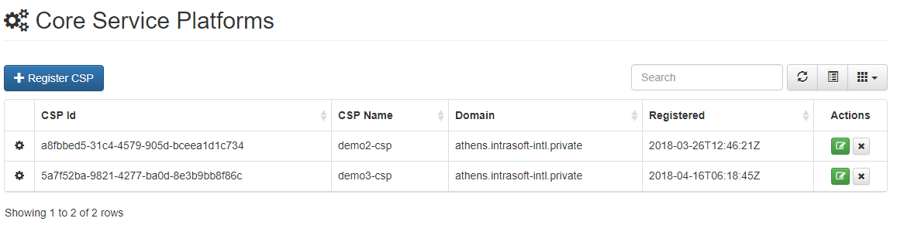

## List of CSPs

As denoted in table columns, administrator is able to monitor the Id, Name, Domain and Registered date of each CSP. Displayed records can be sorted on these attributtes by pressing the corresponding column name either for ascending or descending ordering, as illustrated in the following example.

|  |  |
| --- | --- |
|  |  |
| *Descending sorting on CSP Id column* | *Ascending sorting on CSP Id column* |

Displayed records can be filtered by entering an appropriate search term in the provided text box:

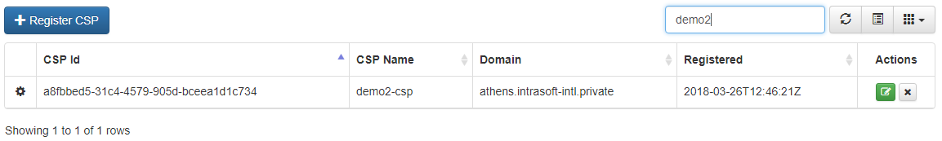

Displayed view can be manually refreshed by pressing the corresponding icon  in the table toolbar.

Table’s toolbar also offers a list layout option by pressing the middle button  with the following result:

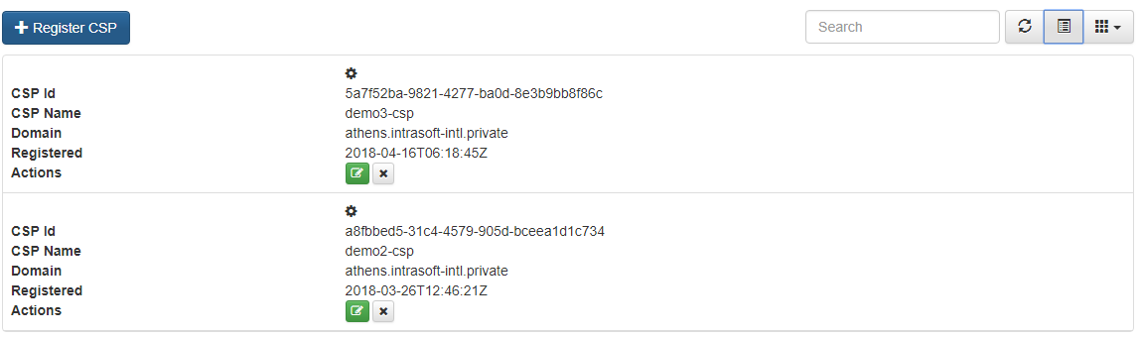

Finally, this page is able to also show Internal/External IPs as well as contacts for each registered CSP, although this information is by default hidden. To view this information, the administrator has to select the corresponding columns from the third button’s dropdown menu:

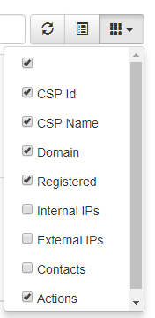

## Updating a registered CSP

Updating the information of a registered CSP can be performed by selecting the edit button  on its row.

CSP information can be edited by the administrator on the fields shown in the figure below:

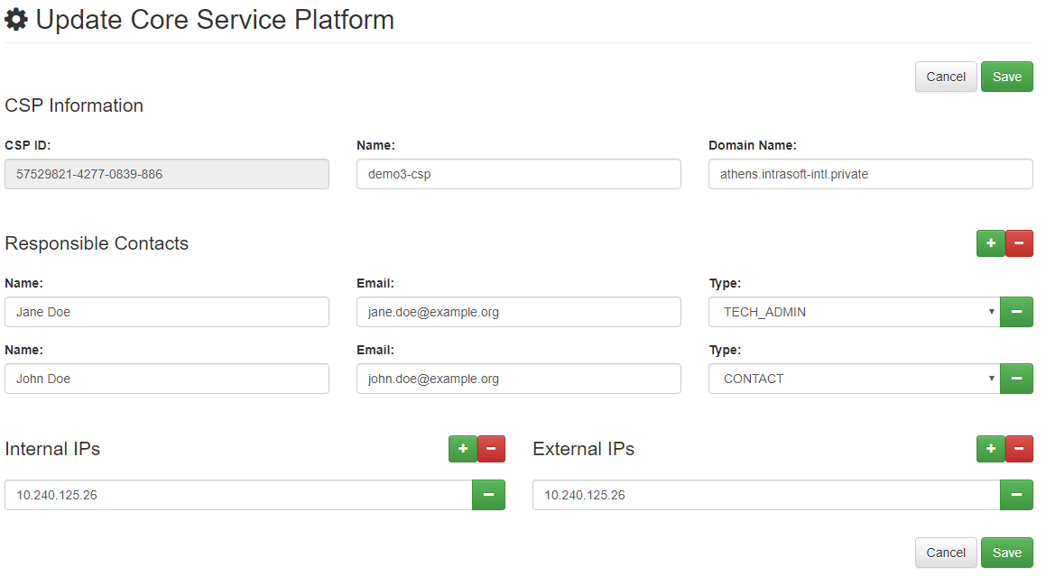

The administrator can alter, add or remove responsible contacts and Internal/External IPs for the specified CSP. However, the minimum responsible contacts that have to be provided are two (2), while the minimum Internal or External IPs that have to be specified are one (1) for each type (at least 1-Internal IP and at least 1-External IP).

After finishing editing the required fields and by pressing the “Save” button, interface informs the administrator for the expected result and if the result was successful he is automatically redirected in the CSP listing page.

Pressing the “Cancel” button returns to CSP listing page, as described in previous paragraph.

## Deleting a registered CSP

Deletion of a registered CSP can be performed by selecting the remove button  on its row. After pressing remove button the administrator is requested twice to confirm the deletion of the specified CSP.

First and second confirmation dialog examples are displayed below:

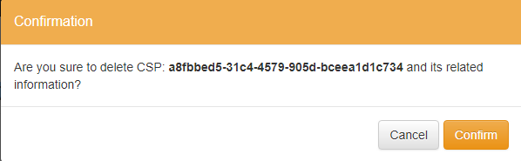

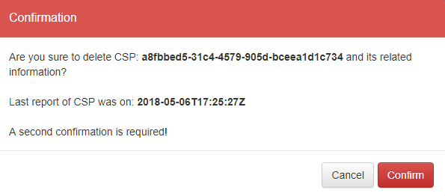

If deletion of a CSP is twice confirmed by the administrator, the interface informs him for the expected result and if the result was successful the CSP listing page gets automatically refreshed.

## Register a new CSP

Although CSPs are intended to be self-registered[1], configuration management offers to the administrator the ability to manually register a CSP. For this to happen the administrator must select the “Register CSP” button and complete the relevant information, as depicted in the figure below:

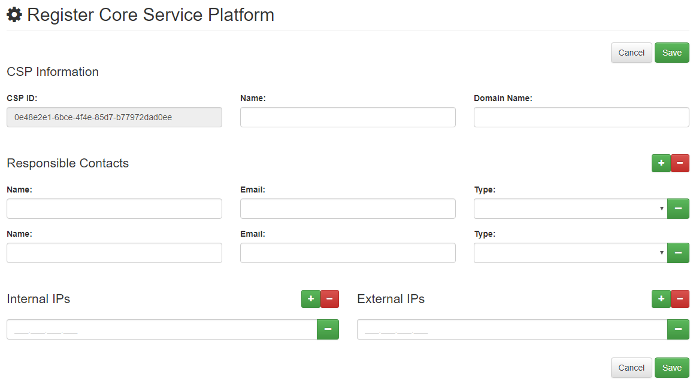

CSP ID field is handled by the system, while the administrator has to complete all the other fields that are required. Please, note that the minimum responsible contacts that have to be provided are two (2), while the minimum Internal or External IPs that have to be specified are one (1) for each type (at least 1-Internal IP and at least 1-External IP).

After completing all the required fields and by pressing the “Save” button, interface informs the administrator for the expected result and if the result was successful he is automatically redirected in the CSP listing page.

Pressing the “Cancel” button returns to CSP listing page.

# Management of Modules

Management of available Modules within the organization can be accessed via menu “Modules” from the top most menu of the interface, and the already registered Modules for the organization are displayed in a table, as shown below:

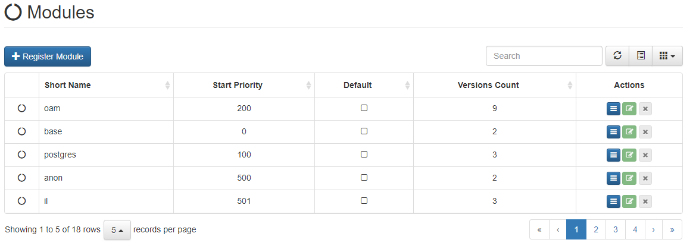

## List of Modules

As denoted in table columns, administrator is able to monitor the Short Name, Start Priority, Default and Versions Count of each Module. Displayed records can be sorted on these attributtes by pressing the corresponding column name either for ascending or descending ordering, as illustrated in the following example.

|  |  |
| --- | --- |
|  |  |
| *Descending sorting on Short Name column* | *Ascending sorting on Short Name column* |

Displayed records can be filtered by entering an appropriate search term in the provided text box:

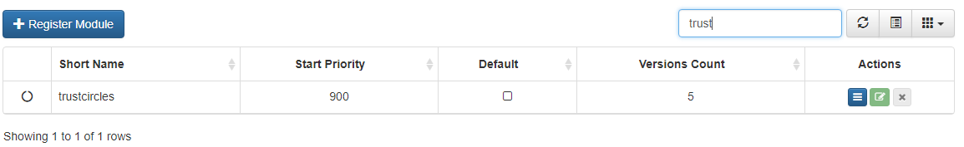

Displayed view can be manually refreshed by pressing the corresponding icon  in the table toolbar.

Table’s toolbar also offers a list layout option by pressing the middle button  with the following result:

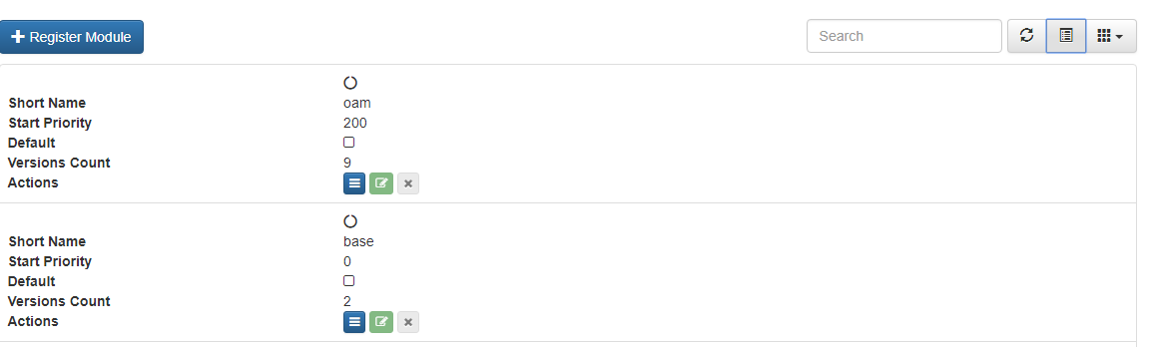

Administrator is able to also show/hide columns according to his preferences from the third button’s dropdown menu:

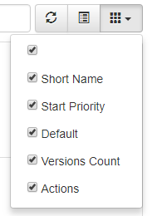

Please note, that all available columns for Modules listing page are displayed by default.

Finally, administrator is able to navigate on the the displayed records via the paging toolbar that exists below the table:



## Updating a registered Module

Updating the information of a registered Module can be performed by selecting the edit button  on its row.

**Please note, that this action is enabled only for Modules that are NOT assigned to a CSP.**

For example, in the following figure, misp Module can’t be edited while mockservices Module can be edited.



Module information can be edited by the administrator on the fields shown in the figure below:

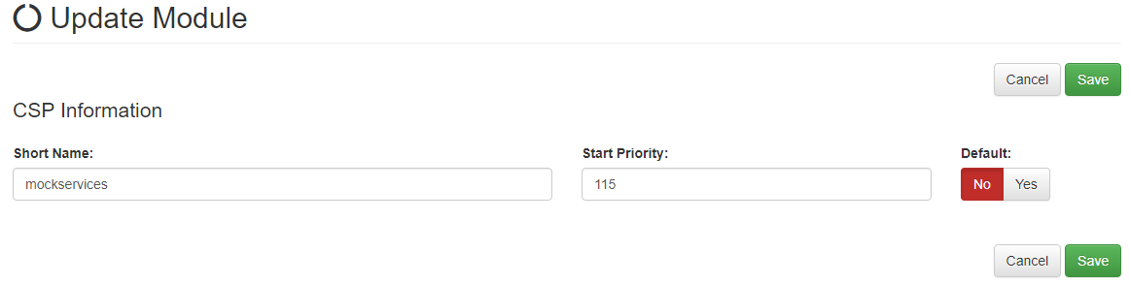

The administrator can alter, Short Name, Start Priority of the Module and set whether this Module is default for all CSPs of the organization or not.

After finishing editing the required fields and by pressing the “Save” button, interface informs the administrator for the expected result and if the result was successful he is automatically redirected in the Module listing page.

Pressing the “Cancel” button returns to Module listing page, as described in previous paragraph.

## Deleting a registered Module

Deletion of a registered Module can be performed by selecting the remove button  on its row.

**Please note, that this action is enabled only for Modules that are NOT assigned to a CSP.**

For example, in the following figure, misp Module can’t be deleted while mockservices Module can be deleted.



After pressing remove button the administrator is requested to confirm the deletion of the specified Module.

A confirmation dialog example is displayed below:

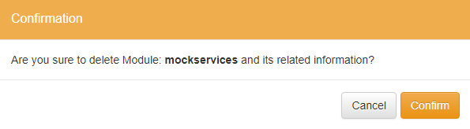

If deletion of a Module is confirmed by the administrator, the interface informs him for the expected result and if the result was successful the Module listing page gets automatically refreshed.

## Register a new Module

Administrator is able register a new Module by selecting “Register Module” button and complete the relevant information, as depicted in the figure below:

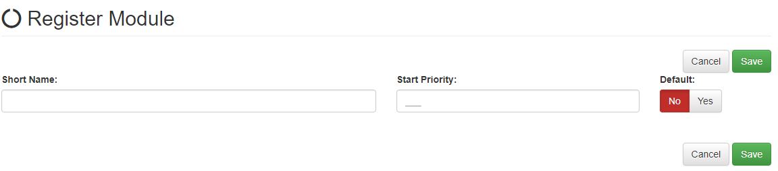

The administrator has to provide, Short Name, Start Priority of the Module and set whether this Module is default for all CSPs of the organization or not.

After completing all the required fields and by pressing the “Save” button, interface informs the administrator for the expected result and if the result was successful he is automatically redirected in the Module listing page.

Pressing the “Cancel” button returns to Module listing page.

# Management of a Module’s Versions

Versions of a registered Module can be managed within the Module listing page, described in previous chapter. The administrator is able to view and manage the versions of a Module by selecting “Modules” from the top most menu and then select the list button on the Module of his interest.

## Listing Module’s Versions

Listing of versions of a Module can be performed by selecting the list button  on its row, within the Module listing page. All registered versions for the specified Module are displayed, as shown below:

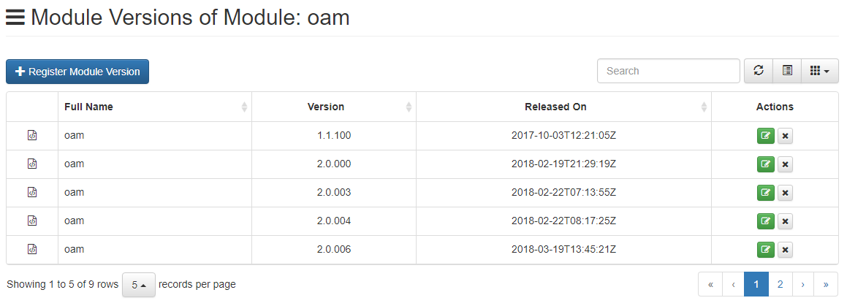

The page offers similar toolbars for searching, paging and displaying in table/list view of the selected Module’s versions.

Extra informayion, that is hidden by default, includes the hash and the description of the Module version, that can be enabled from the third button’s dropdown menu:

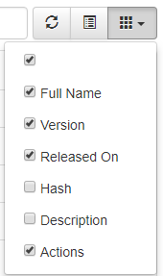

An example is shown below:

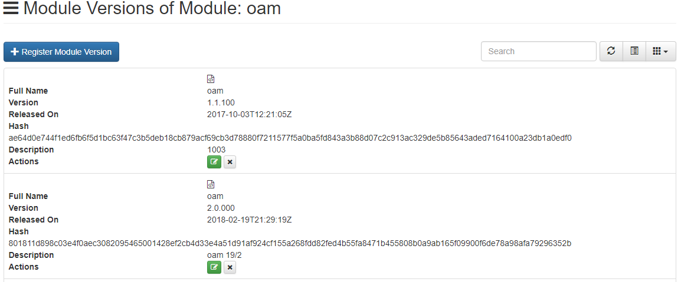

## Updating a registered Module Version

Updating the information of a registered Module Version can be performed by selecting the edit button  on its row, within the selected Module’s Versions listing page.

**Please note, that this action is enabled only for Module Versions that are NOT assigned to a CSP.**

For example, in the following figure, Module oam Version 2.0.007 can be edited while Version 3.5.000 cannot.



Module Version information can be edited by the administrator on the fields shown in the figure below:

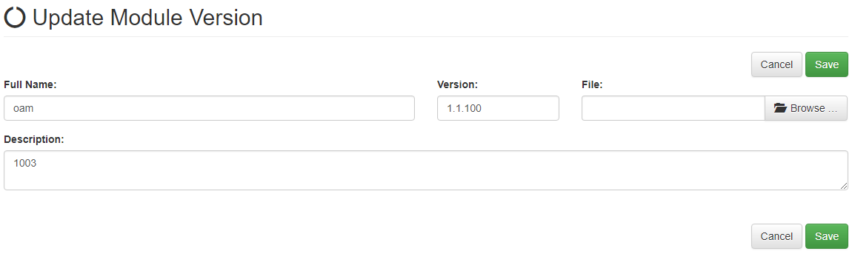

The administrator may alter the fields Full Name, Version and Description and **must** specify a new file for the Module Version file.

**Please note that the only allowed file extension is *.zip, while the ZIP archive has to be flat (without directories within it). Also ZIP file must contain the manifest file, named as: manifest.json.**

More information on how Module Version ZIP files can be created can be found on ANNEX A of this document.

After finishing editing the required fields and by pressing the “Save” button, interface informs the administrator for the expected result and if the result was successful he is automatically redirected in the selected Module’s Versions listing page.

Pressing the “Cancel” button returns to the selected Module’s Versions listing page.

## Deleting a registered Module Version

Deletion of a registered Module Version can be performed by selecting the remove button  on its row, within the selected Module’s Versions listing page.

**Please note, that this action is enabled only for Module Versions that are NOT assigned to a CSP.**

For example, in the following figure, Module oam Version 2.0.007 can be deleted while Version 3.5.000 cannot.



After pressing remove button the administrator is requested to confirm the deletion of the specified Module Version.

A confirmation dialog example is displayed below:

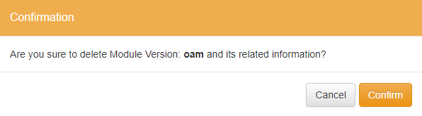

If deletion of a Module Version is confirmed by the administrator, the interface informs him for the expected result and if the result was successful the specified Module’s Versions listing page gets automatically refreshed.

## Register a new Module Version

Administrator is able register a new Module Version for a specified Module by selecting “Register Module Version” button, within the selected Module’s Versions listing page and complete the relevant information, as depicted in the figure below:

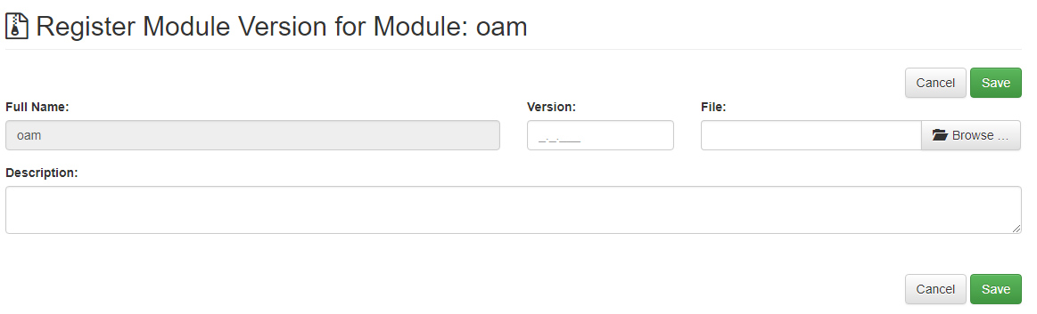

The administrator must complete the fields Full Name, Version and Description and **must** specify a file for the Module Version file.

**Please note that the only allowed file extension is *.zip, while the ZIP archive has to be flat (without directories within it). Also ZIP file must contain the manifest file, named as: manifest.json.**

More information on how Module Version ZIP files can be created can be found on ANNEX A of this document.

After finishing editing the required fields and by pressing the “Save” button, interface informs the administrator for the expected result and if the result was successful he is automatically redirected in the selected Module’s Versions listing page.

Pressing the “Cancel” button returns to the selected Module’s Versions listing page.

# Monitoring and Assignment of Modules Versions to CSPs

Concluding the CSP Configuration Manual and having present the management operations on CSPs, Modules and their Versions, the CSP administrator is also able to specify which Module Version should be delivered to each of the organization’s registered CSPs.

This operation can be performed via the “Dashboard” option from the top most menu.

## Monitoring organization’s registered CSPs

The dashboard page of the configuration interface presents the registered CSPs of the organization, as depicted below:

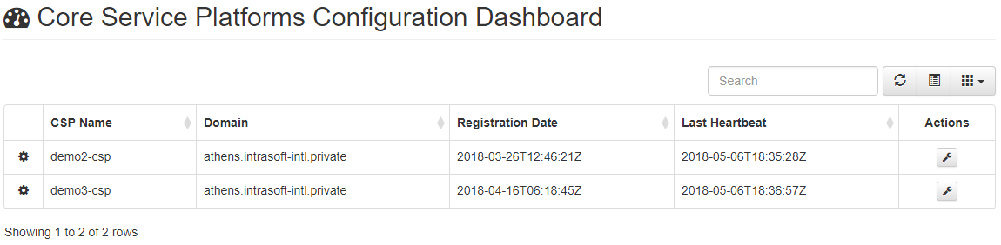

Paging, searching and sorting on the table is available as described previously. Additionally, the administrator is able to effectively monitor the status of each CSP by enabling more columns from the third button’s drop down menu:

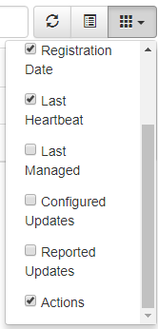

and selecting a list view for more convinience, as shown below, as an example:

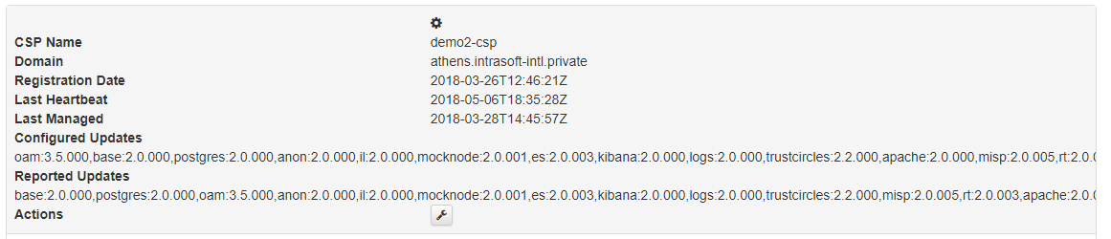

This way the administrator is able to see the Module Versions that have been assigned to be delivered to a dessignated CSP (Configured Updates) and the reported Module Versions from the CSP itself (Reported Updates).

## Assignment of Module’s Versions to organization’s registered CSPs

The assignment of the Version for each registered Module that has to be delivered to a registered CSP of the organization, can be managed by the CSP administrator by selecting the  button for a specific CSP from the dashboard page.

Afterwards, the administrator is able to enable/disable a Module for the selected CSP and also set the desired Version for each Module, as shown below:

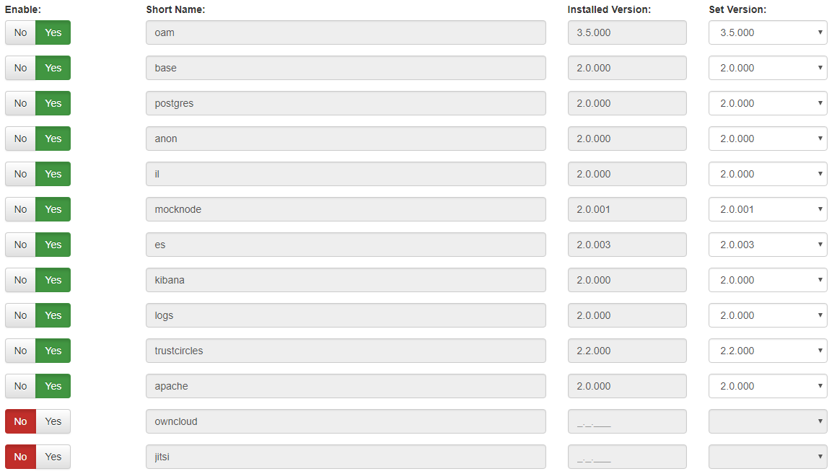

Please note, that all available versions for a Module are listed, so a downgrade or upgrade of a Module is possible, as displayed below, while reported version from the CSP is also displayed here for convinience:

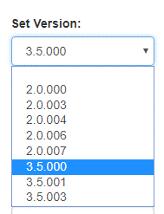

After enabling (or disabling) all desired Modules and setting the desired version for each of them, the administrator is able to save the configuration by pressing the “Save” button, while pressing the “Cancel” button redirects to the dashboard page.

# ANNEX A: Module File Specification of version 4

Below you may find a complete list of CSP module file specifications corresponding to version 4.

Table 1. Complete list of updates/versions per CSP Module regarding version 4

|  |  |  |  |  |
| --- | --- | --- | --- | --- |
| **#** | **Module** | **Version** | **File name** | **Description** |
| 1 | base | 4.0.004 | csp-basemodule-2018-09-03T1243-4.0.4.zip | Updated base modules for 4.0.4 (20180903 build) |
| 2 | postgres | 2.0.000 | csp-postgres-20180216.zip | pg 19/2 |
| 3 | redis | 3.6.001 | csp-redis-20180529-3.6.001.zip | 2018-05-29: added empty “external_host” |
| 4 | oam | 3.6.005 | csp-openam-20180605-3.6.005.zip | 2018-06-05: fix for update-datastore line |
| 5 | cfg | 3.6.006 | csp-configuration-20180626-3.6.000.zip | Port fix |
| 6 | ActiveMQ | 3.8.001 | csp-activemq-20180719-3.8.0.zip | ActiveMQ Module |
| 7 | anon | 4.0.001 | csp-anonymization-20180831-4.0.001.zip | anonymization in arrays element fix |
| 8 | il | 4.0.001 | csp-integrationlayer-20180831-4.0.001.zip | vulnerability routing fixes |
| 9 | mocknode | 2.0.001 | csp-mocknode-20180220.zip | Migrating mockservices to node |
| 10 | es | 4.0.002 | csp-elasticsearch-20180903-4.0.002.zip | Elasticsearch with new misp-vulnerability support latest fix |
| 11 | kibana | 2.0.000 | csp-kibana-20180216.zip | kibana 19/2 |
| 12 | logs | 3.6.007 | csp-logs-20180518-3.6.007.zip | 3.6.007 |
| 13 | owncloud | 3.6.001 | csp-owncloud-20180518-3.6.001.zip | Port moved to 6443 for public access |
| 14 | trustcircles | 3.8.001 | csp-trustcircles-20180801-3.8.001.zip | Fixed TeamContact sharing of field "description" Remove csp_id uniqueness requirement in TeamContacts |
| 15 | misp | 4.0.002 | csp-misp-20180831-4.0.002.zip | fix docker-compose |
| 16 | rt | 3.6.003 | csp-rt-20180620-3.6.003.zip | FIX the https://git-csp.athens.intrasoft-intl.private/csp/sxcsp/issues/4. There are NO log files from RT adapter under /opt/csp/logs added - /opt/csp/logs/:/opt/csplogs to dicker-compose volumes: |
| 17 | intelmq | 4.0.005 | csp-intelmq-20180919-4.0.5.zip | 20180919 build |
| 18 | regrep | 4.0.001 | csp-regularreports-20180831-4.0.001.zip | Regular Reports with the latest fixes |
| 19 | vcb | 3.8.002 | csp-vcb-20180718-3.8.002.zip | vcb:3.8.002 |
| 20 | viper | 4.0.003 | csp-viper-20180831-4.0.003.zip | image fix |
| 21 | apache crl | 4.0.004 | csp-apache-crl-20180917-4.0.4.zip | 20180917 build |
| 22 | apache | 4.0.006 | csp-apache-20180920-4.0.6.zip | 20180920 build |

***Important Notice***

*All modules are assignable either to CSP Central or to a CSP Node* ***except from module named: cfg****, which should be assigned only to the Central CSP*

- End of document-

1. The CSP registering procedure is described in detail in CSP Administration Manual